BOSSUP WEBSITE
BossUp is a digital investment and community-driven funding platform built to empower entrepreneurs and verified projects across East Africa. The platform connects investors, donors, and business owners in a secure, transparent ecosystem where users can invest, donate, and track impact across multiple countries.
BossUp enables country-based project discovery, adaptive local payment methods, and clear money-flow transparency—ensuring trust at every stage of the journey. Investors can explore vetted opportunities, support businesses or social causes, and monitor performance through personalized dashboards, while business owners can create campaigns, receive funding, and manage growth directly on the platform.
By combining technology, trust, and regional focus, BossUp makes investing and community support across East Africa simple, secure, and impactful.
SCREENS /TEMPLATES
- BossUp Landing Page (Initial, then with Clarity & Trust Improvement , then with Invest With Us Section)
- Opportunities Marketplace (Coutry Seecor, Then Display Updated, Then Review Country Filter)
- Campaign Creation Page
- Campain Detail Page (Initial, Then wit Payment & Donor module, then display updated, then Review Investor Journey)
- Investor Dashboard
- Business Owner Dashboard
- Learning Centre
- Admin Panel

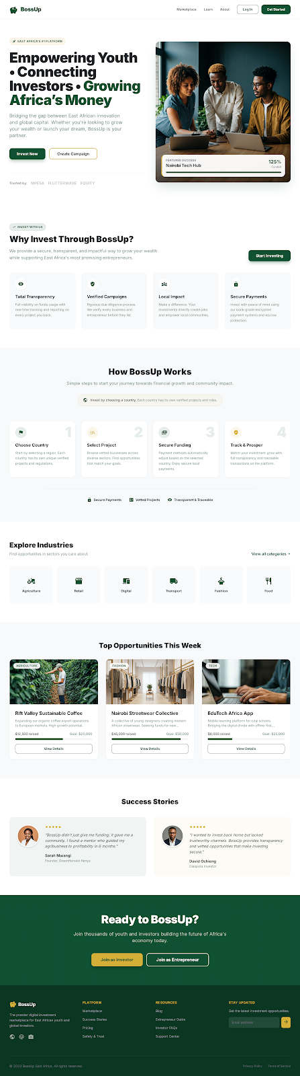
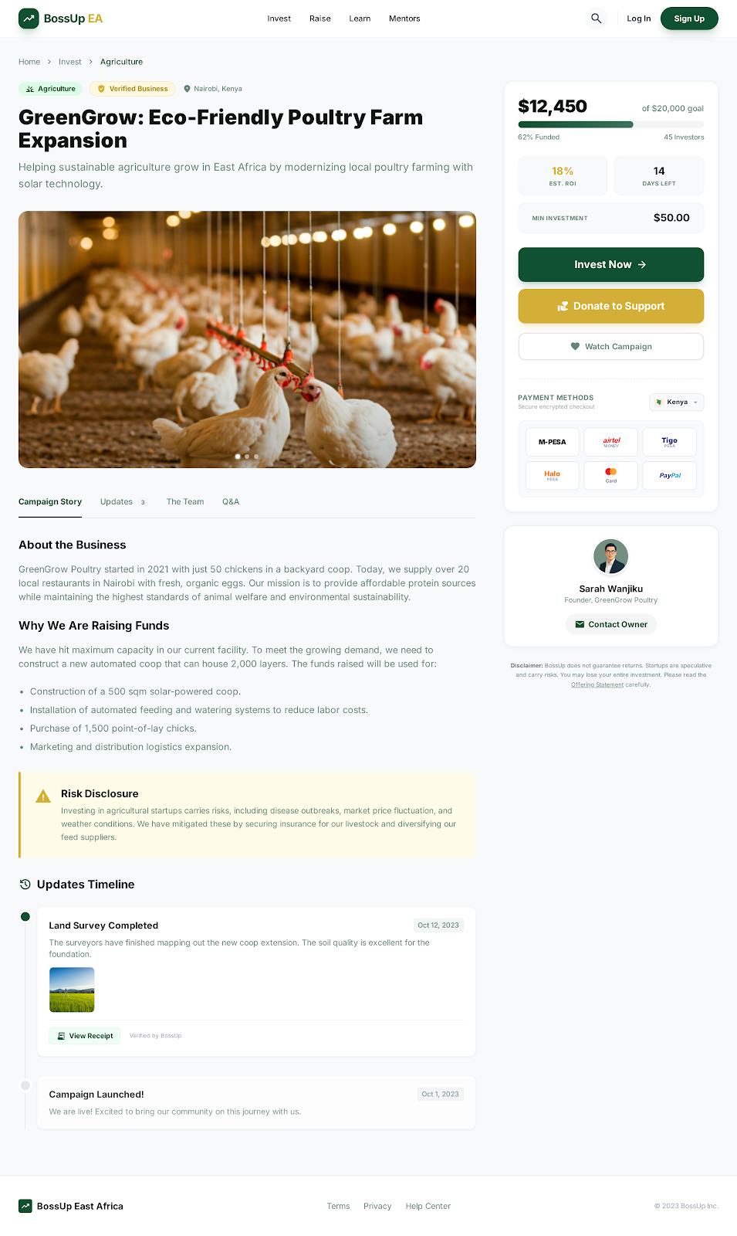
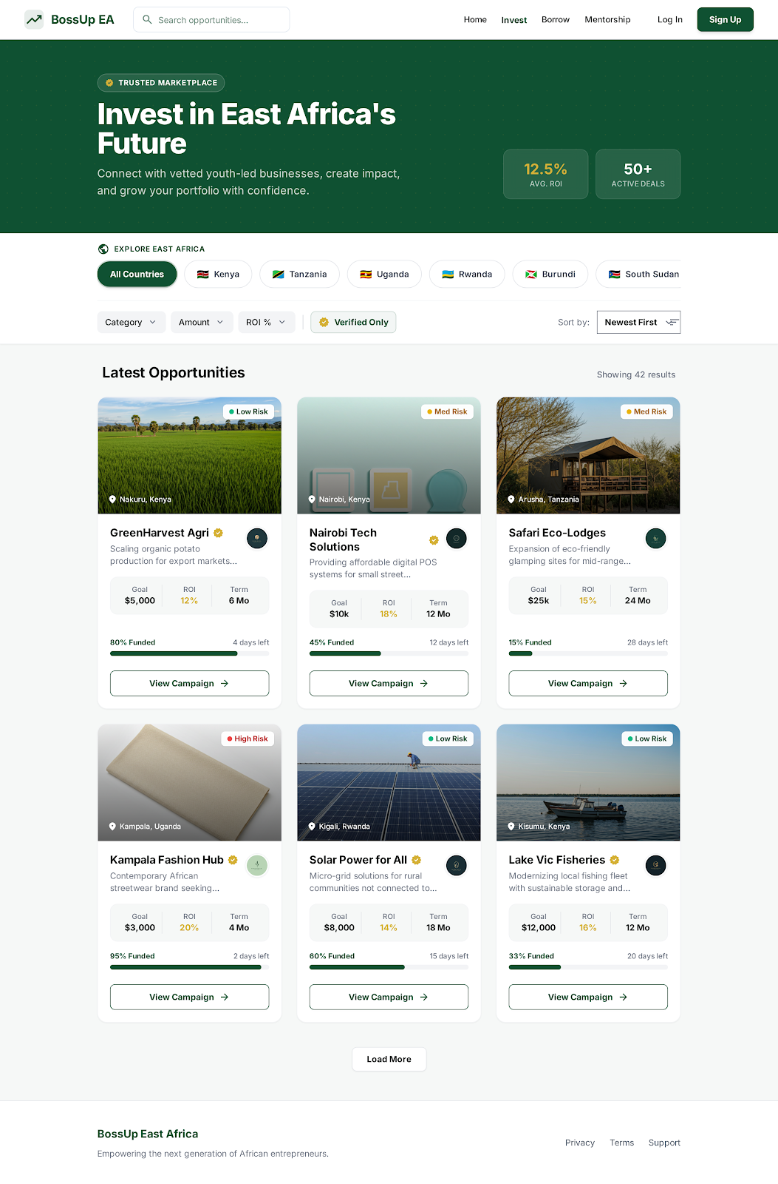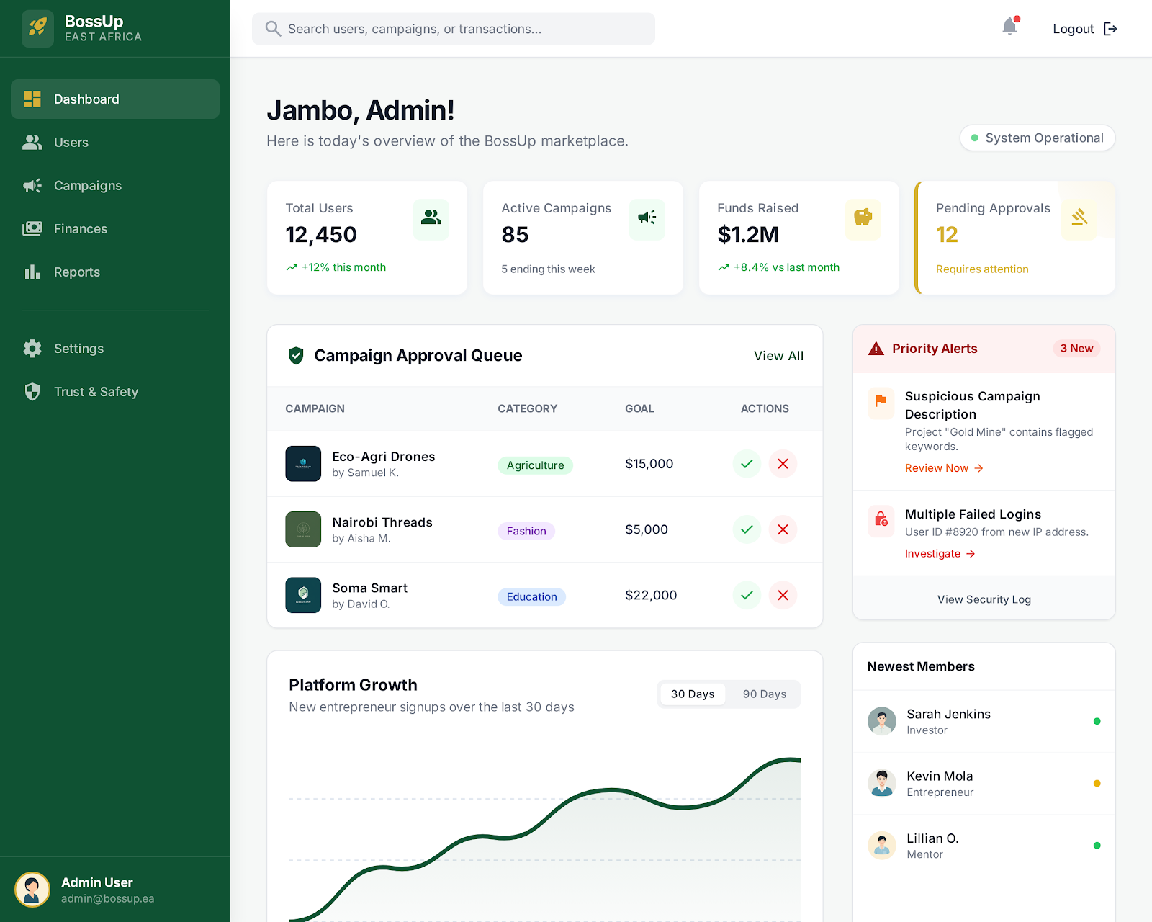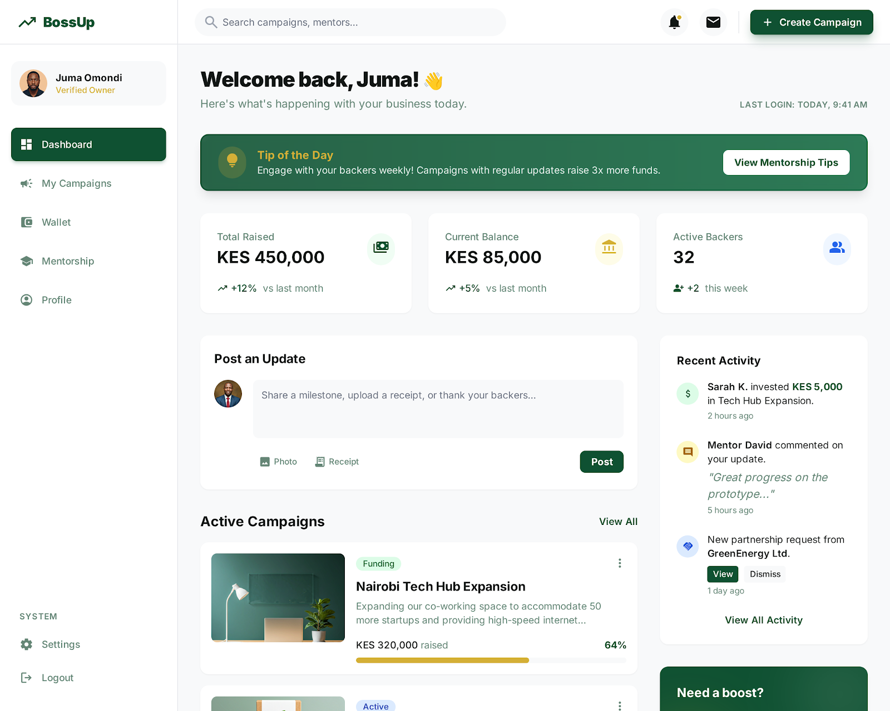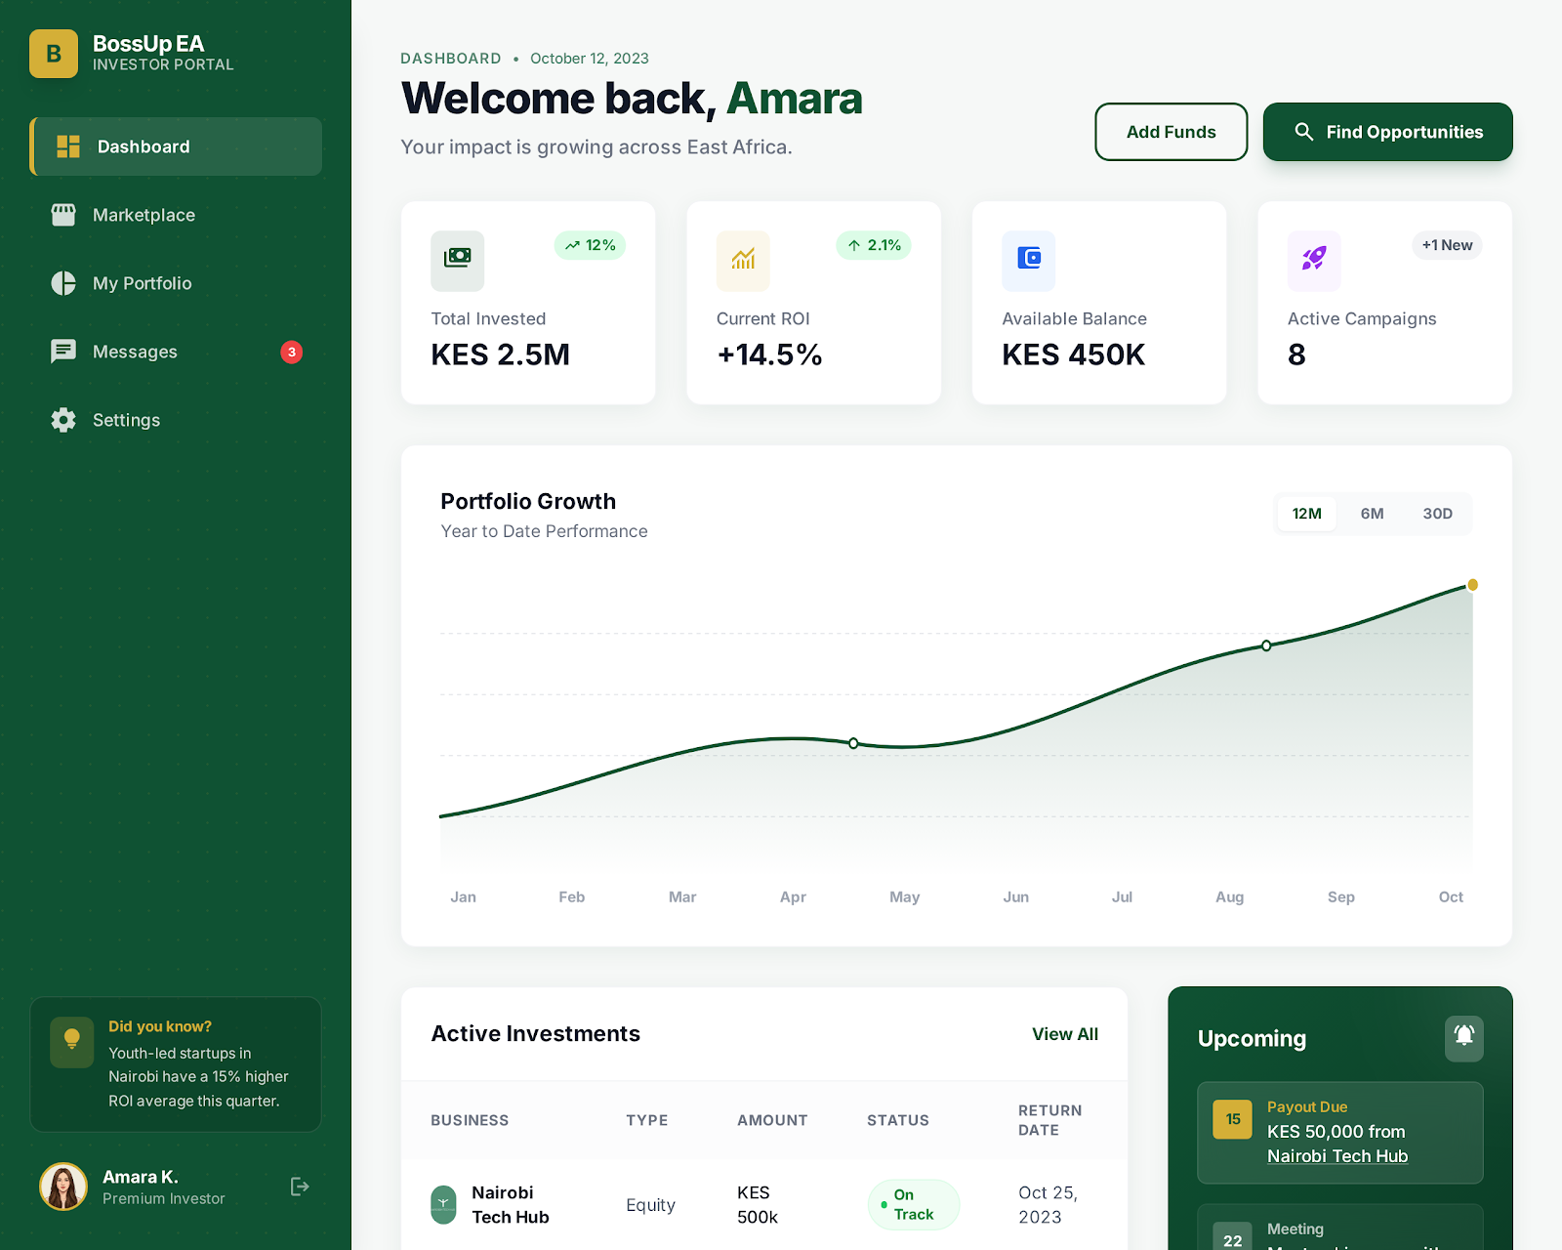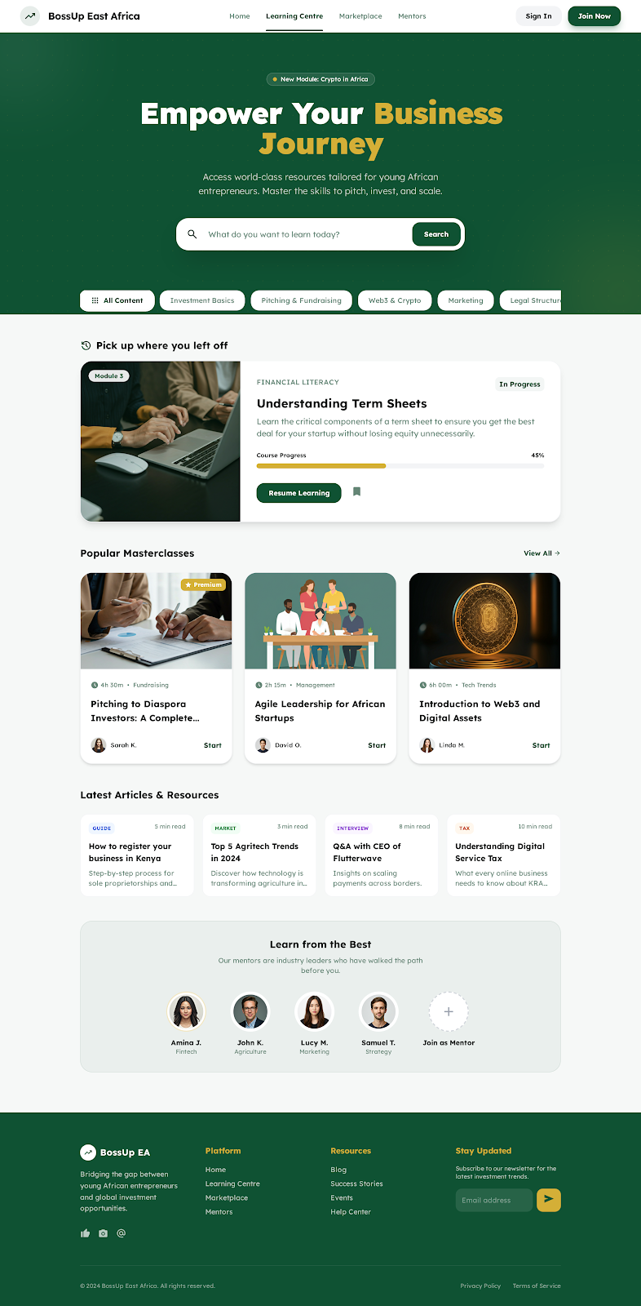
BossUp Platform Wireframe & Page Connectivity
This document explains how all BossUp screens are connected, from the public landing page through user journeys and into the Admin Panel. It is based strictly on the approved scope in BOSSUP WEBSITE.docx.

1. Global Structure Overview
User Types
- Guest (not logged in)
- Investor
- Business Owner
- Admin
High-level flow
Landing Page → Opportunities Marketplace → Campaign Detail →
- Invest / Donate → Investor Dashboard
- Create Campaign → Business Owner Dashboard
Admin Panel oversees everything.

2. Landing Page (Entry Point)
Purpose: Explain BossUp, build trust, and drive users into the platform.

Wireframe Sections
- Top Navigation
  - Logo
  - Opportunities
  - Learning Centre
  - Login / Sign Up
  - Invest With Us (CTA)
- Hero Section
  - Value proposition
  - Primary CTA: Explore Opportunities
  - Secondary CTA: Create a Campaign
- Trust & Clarity Section
  - How BossUp Works (3–4 steps)
  - Country focus (East Africa)
  - Transparency & security highlights
- Featured Opportunities (Preview)
  - 3–6 campaigns
  - Link → Opportunities Marketplace
- Call to Action
  - Become an Investor
  - Raise Funds for Your Business

Navigation Links
- Explore Opportunities → Opportunities Marketplace
- Invest With Us → Sign Up (Investor)
- Create Campaign → Sign Up (Business Owner)
- Learning Centre → Learning Centre

3. Opportunities Marketplace
Purpose: Discover projects by country and category.

Wireframe Layout
- Country Selector (dropdown or tabs)
- Filters
  - Business / Social
  - Funding stage
  - Amount needed
- Campaign Cards
  - Title
  - Country
  - Funding progress
  - CTA: View Campaign

Navigation
- Click Campaign Card → Campaign Detail Page
- Login required only when investing or donating

4. Campaign Detail Page
Purpose: Convert visitors into investors or donors.

Wireframe Sections
- Campaign Overview
  - Cover image
  - Business description
  - Country & category
- Funding Information
  - Target amount
  - Amount raised
  - Progress bar
- Payment & Donor Module
  - Invest / Donate buttons
  - Local payment methods
- Investor Journey Info
  - How returns work (if investment)
  - Impact tracking (if donation)
- Updates Section
  - Campaign updates
  - Milestones

Navigation
- Invest / Donate → Authentication → Investor Dashboard
- Back to Marketplace

5. Authentication (Shared)
Purpose: Route users to the correct dashboard.

Sign Up Options
- Sign up as Investor
- Sign up as Business Owner

Post-login Routing
- Investor → Investor Dashboard
- Business Owner → Business Owner Dashboard
- Admin → Admin Panel

6. Investor Dashboard
Purpose: Track investments, donations, and impact.

Wireframe Sections
- Overview
  - Total invested
  - Active campaigns
  - Returns / impact stats
- My Investments
  - Campaign list
  - Status & performance
- Transactions
  - Payment history
- Profile & Settings

Navigation
- View Campaign → Campaign Detail Page
- Explore More → Opportunities Marketplace

7. Business Owner Dashboard
Purpose: Manage campaigns and funding.

Wireframe Sections
- Overview
  - Total funds raised
  - Active campaigns
- My Campaigns
  - Edit campaign
  - View performance
- Create New Campaign
  - Link → Campaign Creation Page
- Payouts & Transactions
- Profile & Verification Status

8. Campaign Creation Page
Purpose: Allow verified business owners to launch campaigns.

Wireframe Steps
- Business Information
- Campaign Details
- Funding Goals
- Media Uploads
- Review & Submit

Flow
- Submit → Pending Approval → Admin Panel

9. Learning Centre
Purpose: Educate users and build trust.

Content Types
- How investing works
- Risk education
- Business growth resources

Access
- Public (read-only)
- Enhanced content for logged-in users

10. Admin Panel
Purpose: Platform governance and control.

Admin Wireframe Modules
- User Management
  - Investors
  - Business Owners
- Campaign Management
  - Review & approve campaigns
  - Suspend / feature campaigns
- Transactions
  - Monitor payments
  - Resolve disputes
- Country & Payment Config
- Content Management
  - Learning Centre
  - Homepage sections

Control Scope
Admin has visibility and control over all platform data.

11. Full Navigation Map (Simplified)
Landing Page
→ Opportunities Marketplace
→ Campaign Detail
→ Auth
→ Investor Dashboard
Landing Page
→ Sign Up (Business Owner)
→ Campaign Creation
→ Admin Approval
→ Business Owner Dashboard
Admin Panel
↔ All Users, Campaigns, Payments

Perfect. Since you’re moving straight into coding, what you need now is a single, authoritative Stitch prompt that tells it exactly what to build — no ambiguity, no product drift.
Below is a FULL, READY-TO-PASTE STITCH PROMPT covering (1) Technical Architecture and (4) Security, KYC & Trust Model, aligned 100% with BossUp and your approved screens.

✅ FULL STITCH PROMPT — BOSSUP (TECH + SECURITY)

Project Context
You are building BossUp, a digital investment and community-driven funding platform for East Africa. The platform connects Investors, Business Owners, and Admins in a secure, transparent ecosystem that supports investing, donating, and impact tracking across multiple countries.
This prompt defines the technical architecture, authentication, payments, security, and KYC model. UI screens already exist and must be respected.

1. Core Architecture Overview

Frontend
- Framework: React (or Next.js if SSR is needed)
- Routing: Role-based routing
- State: Auth state, user role, session, payment status
- Pages:
  - Landing Page
  - Opportunities Marketplace
  - Campaign Detail Page
  - Authentication (Login / Sign Up)
  - Investor Dashboard
  - Business Owner Dashboard
  - Campaign Creation Page
  - Learning Centre
  - Admin Panel

Backend
- Framework: Node.js (NestJS / Express) OR FastAPI
- API type: REST
- Authentication: JWT (access + refresh tokens)
- Role-based access control (RBAC)
- Database: PostgreSQL (recommended)
- Payments: Gateway abstraction layer (country-based)

2. Authentication & Authorization (MANDATORY)

User Roles
- INVESTOR
- BUSINESS_OWNER
- ADMIN

Auth Flow
- User hits any protected action (Invest, Create Campaign)
- If unauthenticated → redirect to Auth
- User signs up or logs in
- JWT issued with role & permissions
- User routed to correct dashboard

Sign-Up Logic
- Investor:
  - Name, Email, Password, Country
  - Email verification required
- Business Owner:
  - Name, Email, Password, Business name, Country
  - KYC status = PENDING
- Admin:
  - Created manually (no public signup)

Access Rules
- Investors:
  - View campaigns
  - Invest / donate
  - View their own transactions
- Business Owners:
  - Create campaigns
  - View only their campaigns & funds
- Admin:
  - Full system access

3. Payment Gateway Architecture

Payment Design
- No direct gateway logic in frontend
- Frontend calls backend payment endpoints
- Backend selects gateway based on:
  - User country
  - Campaign country
  - Payment type (investment vs donation)

Payment Flow
- User clicks Invest / Donate
- Auth check
- Backend creates payment intent
- Gateway processes payment
- Webhook confirms payment
- Backend:
  - Updates transaction table
  - Updates campaign funding progress
  - Logs audit record
- User redirected to Investor Dashboard

Payment Entities
- Transaction
- PaymentGateway
- CampaignFunding
- AuditLog

4. Campaign Lifecycle & Approval

Campaign Creation
- Business Owner submits campaign
- Status = PENDING_APPROVAL
- Admin reviews:
  - Approve → status = LIVE
  - Reject → status = REJECTED
- Only LIVE campaigns appear in Marketplace

5. Security Model (CRITICAL)

Core Security Principles
- JWT with short-lived access tokens
- Refresh token rotation
- Password hashing (bcrypt / argon2)
- HTTPS only
- Rate limiting on auth & payments
- Input validation on all endpoints

Role Enforcement
- Backend enforces permissions (never frontend-only)
- Middleware checks:
  - Authenticated
  - Role
  - Ownership (campaign owner vs investor)

Audit Logging
- Log:
  - Login attempts
  - Payments
  - Campaign approvals
  - Admin actions

6. KYC & Trust Model

KYC States (Business Owners)
- NOT_SUBMITTED
- PENDING
- VERIFIED
- REJECTED

KYC Requirements (Phase 1 – Manual)
- Business registration document
- Government ID
- Bank / payout details

Trust Indicators (Frontend)
- Verified badge on campaigns
- Country & payment transparency
- Funding progress visibility
- Campaign updates section

7. Admin Panel Responsibilities

Admin Capabilities
- Approve / reject campaigns
- Verify business owners
- View all transactions
- Enable/disable payment gateways per country
- Flag suspicious activity
- Edit homepage content

Admin Restrictions
- No direct fund manipulation
- All admin actions logged

8. Database Core Tables (MINIMUM)
- users
- roles
- campaigns
- campaign_updates
- transactions
- payment_gateways
- kyc_records
- audit_logs

9. Non-Negotiable Rules
- No payments without backend verification
- No campaign goes live without admin approval
- No dashboard access without role-based auth
- No frontend-only security logic

10. Output Expected from Stitch
- Backend architecture diagram
- Auth & RBAC flow
- Payment sequence diagram
- API endpoint list
- Database schema
- Security enforcement points

IMPORTANT
Do NOT redesign screens.
Do NOT change user roles.
Do NOT add new features beyond scope.
Focus on production-ready architecture.

Programming Tools
Frontend: HTML/CSS/JS (or React)
Backend: FastAPI (Python)
Payments: Backend-only integration
Auth: JWT

